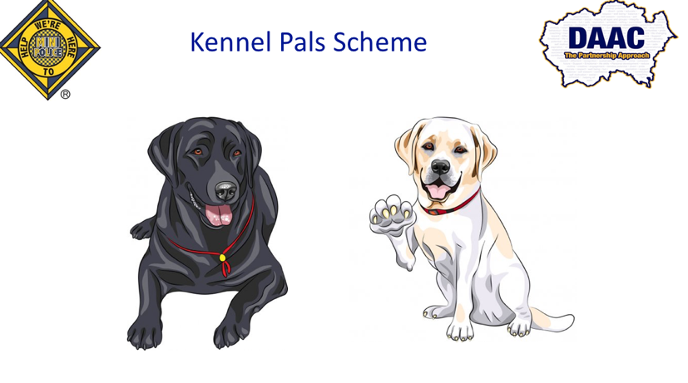

Kennel Pals is a new opportunity for the Mini Police schools.

Each school will be given a designated kennel pal dog, and they will receive termly pup dates about the dog. The pup date will allocate a task for the Mini Police to complete that term.
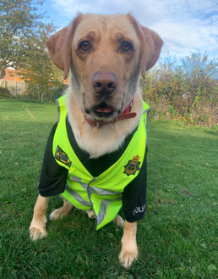

The Mini Police will then send evidence of themselves completing the task to our DAAC team, such as pictures, recordings etc.

We will then award relevant points to that school which can be used as part of our Mini Police reward scheme to gain prizes and activities for your school.

Please contact minipoliceinfo@daac.org.uk

